**Project Design Phase-II**

**Data Flow Diagram &User Stories**

|  |  |
| --- | --- |
| Date | 31 October 2022 |
| Team ID | PNT2022TMID46949 |
| Project Name | Classification Of Arrhythmia By Using Deep Learning With 2D-ECG Spectral Image Representation |
| Maximum Marks | 4 Marks |

**Data Flow Diagrams:**

A Data Flow Diagram (DFD) is a traditional visual representation of the information flows within a system. A neat and clear DFD can depict the right amount of the system requirement graphically. It shows how data enters and leaves the system, what changes the information, and where data is stored.

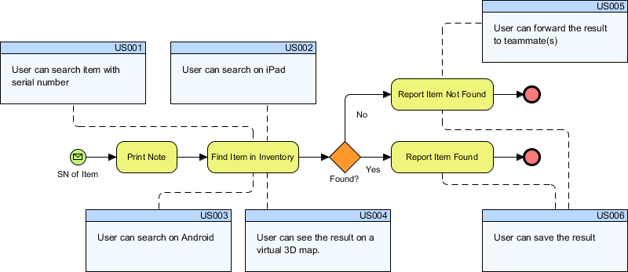

**User Stories**

Use the below template to list all the user stories for the product.

| **User Type** | **Functional Requirement (Epic)** | **User Story Number** | **User Story / Task** | **Acceptance criteria** | **Priority** | **Release** |
| --- | --- | --- | --- | --- | --- | --- |
| Customer (Mobile user) | Registration | USN-1 | As a user, I can register for the application by entering my email, password, and confirming my password. | I can access my account / dashboard | High | Sprint-1 |
| Customer  (Service) | Dashboard | USN-2 | As a user, I will receive confirmation email once I have registered for the application | I can receive confirmation email & click confirm | High | Sprint-1 |
| Customer  (Register) | Login | USN-3 | As a user, I can register for the application through Facebook | I can register & access the dashboard with Facebook Login | Low | Sprint-2 |
| Customer  (Application) | Registration | USN-4 | As a user, I can register for the application through Gmail | I can register & access the dashboard | Medium | Sprint-1 |
| Customer  (Login) | Login | USN-5 | As a user, I can log into the application by entering email & password | I can access & Login email & password | High | Sprint-1 |
| Customer  (Evaluation) | Dashboard | USN-5 | As Max, I want to invite my friends, so we can enjoy this service together. | I can register & dashboard evaluated | Low | Sprint-2 |
| Customer (Web user) | Registration | USN-1 | As a user story is **an informal, general explanation of a software feature written from the perspective of the end user or customer**. The purpose of a user story is to articulate how a piece of work will deliver a particular value back to the customer. | I can register & login the web user | High | Sprint-2 |
| Customer Care Executive | Dashboard |  | A customer care executive is a professional responsible for communicating the how's and why's regarding service expectations within a company. | I can dashboard& customer service team. | Low | Sprint-1 |
| Administrator | Dashboard |  | Tasks are **used to break down user stories even further**. Tasks are the smallest unit used in scrum to track work. A task should be completed by one person on the team, though the team may choose to pair up when doing the work. | I can dashboard & register track work | Medium | Sprint -1 |